Deep Learning – SP20

Notes, links, and resources for the class

# Description

This course concerns the latest techniques in deep learning and representation learning, focusing on supervised and unsupervised deep learning, embedding methods, metric learning, convolutional net and recurrent nets, with applications to computer vision, natural language understanding, and speech recognition. The prerequisites include: DS-GA 1001 Intro to Data Science or a graduate-level machine learning course.

# Links

* Course public folder: bit.ly/DLSP20.
* Class website [here](https://atcold.github.io/pytorch-Deep-Learning).
* Piazza Q&A interface available [here](https://piazza.com/nyu/spring2020/dsga1008/resources). Sign-up token: DLSP20.
* Lecture/Lab Scribe Sign-up [here.](https://docs.google.com/spreadsheets/u/2/d/1b7sx6laPYK62KoXqejrsxUJjUuVcSJ28gswBvTSq8GU/edit#gid=0)

Video recordings:

1. NYU student? Go to NYU classes -> Panopto.
2. Non-NYU student? [YouTube playlist](https://www.youtube.com/playlist?list=PLLHTzKZzVU9eaEyErdV26ikyolxOsz6mq).

# Lecture Notes

Students will **collaborate** on writing up and editing lecture and lab notes in groups of 4 (3 writers + 1 editor) for every hour (50 min) of class. This means **two groups of 4** per lecture and **one group of 4** per lab. All 8 scribes per lecture submit one cohesive set of notes in the form of Markdown source code. Similarly, 4 scribes per lab submit one document. You may use [hackMD](https://hackmd.io/) for generating the collaborative Markdown document; nevertheless, you will have to submit a pull request with the finished document to the [main repository](https://github.com/Atcold/pytorch-Deep-Learning-Minicourse/tree/master/docs/chapters) (see the rendered notes at the class materials link above). Sign up for scribe duties [here (sheet in this google folder)](https://docs.google.com/spreadsheets/d/1b7sx6laPYK62KoXqejrsxUJjUuVcSJ28gswBvTSq8GU/edit#gid=0).

## Writer instructions

* Annotate ~15 minutes of class.
* Choose a title for your subsection.
* Mark down start / end minute on class video recording (from NYU Classes / Panopto). There should not be temporal gaps between consecutive subsections.
* Write ~300 words, formulas included (see style guide).
* Read one subsection before and after yours (this will span across weeks if your subsection is the first / last), work together the two corresponding editors to make the three subsections legible and uniform.

## Editor instructions

* Review the assigned section (3 subsections) for readability, typos, formatting (see style guide), start / end time stamps.
* Come up with a title for the section you’re reviewing.
* Write a ~50 word summary of the section and use it as text in your PR (pull request).
* Read one section before / after (this will span across weeks), add cross references, fix typos and inconsistencies, remove figure duplicates, etc…

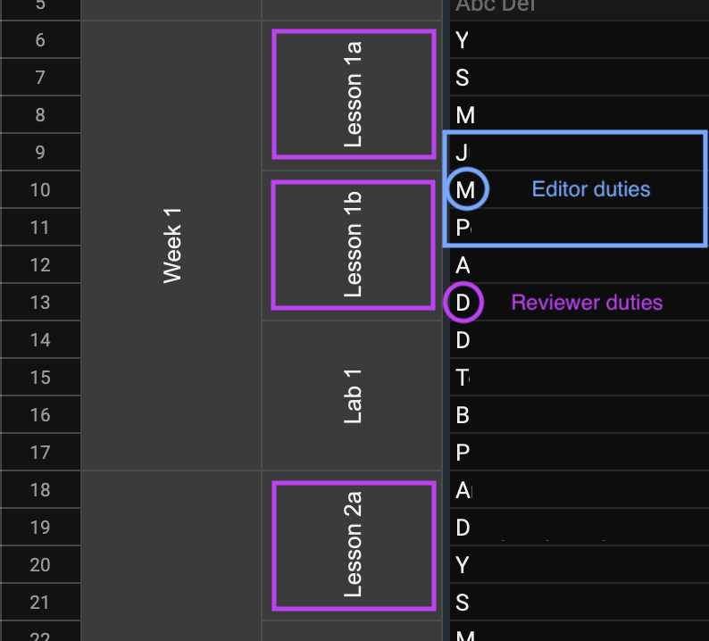

Part 1 of lectures on Monday takes place from 4:55pm to 5:45pm. Part 2 of lectures on Monday takes place from 5:45pm to 6:35pm. The write-up for a given class meeting is due a week after it takes place. Sunday (Monday) evening is best so that students can read before class (lab) on Monday (Tuesday).

Detailed instructions how to write/submit lecture notes are [here](https://github.com/Atcold/SP19-DL-collaborative-notes/blob/master/instructions.tex).

# People

Yann LeCun - yann [ at ] cs.nyu.edu

Alfredo Canziani - canziani [ at ] nyu.edu

Mark Goldstein - goldstein [ at ] nyu.edu

## Graders

1. Serkan Karakulak <[sk7685@nyu.edu](mailto:sk7685@nyu.edu)>
2. Raghav Jajodia <[rj1408@nyu.edu](mailto:rj1408@nyu.edu)>
3. Priyank Pathak <[pp1953@nyu.edu](mailto:pp1953@nyu.edu)>
4. Chiao-Hsun Wang <[chw371@nyu.edu](mailto:chw371@nyu.edu)>
5. Pedro Manuel Herrero Vidal <[pmh314@nyu.edu](mailto:pmh314@nyu.edu)>
6. Bixing Yan <[by783@nyu.edu](mailto:by783@nyu.edu)>

# Logistics

## Grading, undergraduates and masters (default)

30% Homework.

30% Mid-term knowledge test on a date to be determined.

30% 2 or 3 people group project, 3 minute video presentation (up to 6 slides), plus short ICLR like article.

±10% lecture write-up (so do your work).

5% forum answers.

## Grading, doctorate candidates (requires approval)

60% Individual deep learning research.

30% Mid-term knowledge test.

±10% lecture write-up.

## HPC

Everyone in the class will receive access to the NYU HPC cluster in the second half of the course. Instructions on how to use it can be found [here](https://drive.google.com/open?id=1gh5HmFa4D8Etor2zMnMwBdppgA9nOqfs).

## Overleaf

NYU has free access to Overleaf for all faculty and students at <https://www.overleaf.com/edu/nyu>.

You may want to use it for organising (among yourselves) the individual contribution to the lecture notes.

# Office Hours

**Y**ou find us on Piazza :p Your questions are likely to be others’ questions as well. So, it’s nice to have them all in one place. Also, answering others’ questions will give you extra bonus points.

# Homework

There will be homework assignments due roughly every 2 weeks. More details will be added here as we progress through the semester. **No late submissions will be accepted**. If you have any special circumstances, please reach out to the TAs before the submission deadline.

### Homework Assignment 1: TBA

Due ~ mid February

### Homework Assignment 2: TBA

Due ~ beginning of March

### Homework Assignment 3: TBA

Due ~ end of March